FYP Interim Report

*Monitoring User Preferences - An Application to Desktop Environments*

Supervisor: Dr Jesús García Galán

Student: Michael Hallinan - 12134635

Table of Contents

|  |  |
| --- | --- |
| Section Title | Page |
| Table of Contents | *1* |
| Project Summary | *2* |
| 1. Introduction and Objectives | *3* |
| 1.1 Introduction | *3* |
| 1.2 Motivation | *4* |
| 1.3 Objectives of Project | *5* |
| 2. Research | *6* |
| 2.1 Introduction | *6* |
| 2.2 Papers | *6* |
| 2.3 Existing Projects | *7* |
| 2.4 Other Sources | *7* |
| 3. Description of Current Progress | *10* |
| 3.1 Introduction | *10* |
| 3.2 Initial Plans | *10* |
| 3.3 Problems Faced | *13* |
| 4. Project Plan | *15* |
| 4.1 Introduction | *15* |
| 4.2 Possible Modification | *15* |
| 4.3 Implementation | *15* |
| 4.4 Testing and Evaluation | *16* |

Project Summary

Monitoring User Preferences - An Application to Desktop Environments

*A critical requirement of software systems is to satisfy the needs of the user.*

The focus of this project will be on desktop environments and will be aimed to identify strategies to capture user preferences and detect changes. This is intended to be done explicitly by requesting user feedback, as well as implicitly through mining of user behaviour or system logs.

Proper user preference specification is believed to be very important for maximum user enjoyment when using software. This project will focus upon acquiring these specifications through monitoring the user and to apply this information to create adaptive software tailored to the individual user.

Many users are not fully aware of the configuration capabilities of a system. Advanced configuration options can also intimidate novice users of a system. This project will seek to present a simple configuration but allow for more complicated configuration through its use of user-profiling. The chosen solution will perform this through the monitoring of user activity on the Netflix application and will provide unobtrusive configuration options throughout the program as well as providing a recommender system more closely tailored to the individuals preferences.

This report is organised as follows. The following section, **Chapter 1: Introduction**, will further explain what is meant by “Monitoring User Preferences” as well as describing the project in detail. **Chapter 2:** **Research** will describe the research done in order to prepare for the project including papers read and existing projects. **Chapter 3: Details of Current Progress** details the non-research work completed at the time of the writing of this report and **Chapter 4: Project Plan** will illustrate the work to be done before the project is finished.

1: Introduction and Objectives

# 1.1 Introduction

## Description

The enormous growth in web content and software applications as well as the increased popularity of these products has led to increased demands for user accessibility. In recent years, there has been much effort put into developing user-adaptive web-sites and applications (Perkowitz & Etzoni, 1999).

Though many techniques exist, a commonly used method is based upon monitoring User Preferences. User preferences are frequently assessed in order to improve the user experience.

This project is intended to study and monitor these preferences in order to allow for the optimal experience for users of all levels.

This will be accomplished through the gathering of information from the user and modification of the desktop environment accordingly. This will be done explicitly through user feedback such as user-defined settings or implicitly through data logging and mining.

Many existing studies and papers have already dealt with similar topics and these will be detailed later in the **Research** section of the report. This project is intended to focus some of these studies into a single project.

### User Preferences

A user is any person who uses a computer or network service. User Preferences can be described as “Specifications or settings for features of a software program as defined by the user.”

Another term frequently used for the type of study is “User Profiling”. A user profile has been defined as the description of the user interests, characteristics, behaviours, and preferences. User profiling is the practice of gathering, organizing, and interpreting the user profile information. (Godoy & Amandi, 2005)

These are frequently options selected by users in order to simplify or enhance their experience while using a software program. Explicitly defined examples include simple alterations such as colour, font, or language as well as more advanced modifications such as key-binding or behavioural changes.

A common example of implicit information gathering would be the use of link personalisation to recommend items based on buying history or ratings by e-commerce applications. This is detailed further in (Rossi, et al., 2001)

## Overview

Though numerous ideas and possible proposals were considered, the approach selected for this project is an extension designed for Netflix, a popular movie and television streaming service.

The goals for the planned extension are for it to contain various methods of retrieving data from the user through feedback such as buttons and option pages, as well as monitoring the user tastes in movies and television shows in order to further present recommendations and alter the interface accordingly.

# 1.2 Motivation

When setting out to do my final year project I felt it was important to work in an area that interested me but was also potentially useful, as well as integrating aspects of the degree programme and subjects I had learned over the 4 years.

I have been interested in Artificial Intelligence and Machine Learning mostly due to the crossover between a number of subjects that had interested me for a long time, namely data analysis (Witten, et al., 2011), evolutionary theory (Sipper, et al., 1997), and neuroscience and psychology (Vogeley & Bente, 2010). I had originally intended to do a personal project of a desktop-based voice-operated system based upon learning user behavioural patterns and understanding unstructured commands similar to (Barakova, et al., 2011). After researching this idea I decided that unfortunately it was too large and considered it too aspirational and held too much of a risk for my final year project.

One of the proposed ideas dealt with a similar idea albeit in a more manageable capacity. I chose this idea as it dealt with user profiling and user preferences, which I felt to be close enough to my original idea to remain interesting as well as being a subject applicable to additional fields. Further research into this field provoked increased interest due to realisations of the broad applicability of the research. It highlighted the use of user-profiling in many recognisable and commonly used features, such as Amazon and Google ads. The remaining possible applications for user interactability rather than being simply used as customer profiling also seemed highly interesting with possibilities for adaptive interfaces and automatically personalised web applications.

# 1.3 Objectives of Project

The objectives of this project will be to create a program capable of adapting to the user’s requirements. This will be done as mentioned previously through the monitoring of the user’s habits and preferences. This project will then be distributed for testing and results of this testing will be analysed further in accordance with the ideals of the proposed topic. These findings will then be compiled into a report in order to further express the results of the project.

Prior to conducting this research, I felt it necessary to examine existing research in this area. This existing research has been presented in **Chapter 2** along with a summary of the initial findings, while **Chapter 3** and **Chapter 4** will present work that has been completed thus far and the plans for the work yet to be completed.

2: Research

# 2.1 Introduction

An important part of the project is the research and reasoning behind any decisions made. Numerous studies and papers exist in similar fields and these were consulted during the initial stages of the project. A number of papers were supplied by the supervisor and through the use of Google Scholar, more papers were found. These papers were viewed using the University of Limerick Library’s services, and the books used for studying were also borrowed from the library.

A large portion of the first semester was spent researching the topic and forming possible ideas for the project. Below you will find the research papers that were read as well as any similar existing projects reviewed. You will also find the books and other sources that were consulted as part of the research.

# 2.2 Research Papers

The initial papers consulted were *Creating Evolving User Behavior Profiles Automatically* (Iglesias, et al., 2012) and *Preference Mining: A Novel Approach on Mining User Preferences for Personalized Applications* (Holland, et al., 2003), among others. These papers were useful in detailing proper recording technique as well as showing previous studies in order to help form an idea for a possible solution for the project.

References from these papers were consulted for further reading material. Google Scholar was also consulted to find more recent papers referencing these sources. These efforts led me to *Detecting innovative topics based on user-interest ontology* (Nakatsuji, et al., 2009) and *User Preference Mining Techniques for Personalized Applications* (Holland & Kießling, 2004)*.*

These papers spoke further about the processing of the information, such as mining algorithms and applications of the information. The subjects of both papers were based upon web-based applications which helped to cement the decision to work on a web-based application for the project.

The papers spoke at length about the algorithms used and processing methods but were brief with the description of how they would gather the information. It was necessary to look elsewhere in order to find other methods of gathering the information for processing.

# 2.3 Existing Projects

The most prevalent example found of proper monitoring of User Preferences is Google Now by Google. This application gathers information from users’ search history in order to display possibly useful material related to fields the user may be interested in. The application can then gather explicit information from the user such as feedback to this material or selection of certain fields such as “Home” location. This clearly displays both implicit (material) and explicit (feedback) information gathering. It also processes this information to display information relative to the user, as is intended by our application.

Based upon the idea of a Netflix extension for Chrome, many similar extensions already exist. Though these applications are less focused upon adaptive interfaces and information gathering, they do perform actions similar to those desired by the project application. A primary example of a similar extension is “Flix Plus” by Life Hacker. This extension performed many of the desired operations for the application such as information gathering, image overlay on shows, as well as a highly customisable User Interface. This extension failed to display any signs of adaptive interface or user profiling however.

# 2.4 Other Sources

Other than existing Academic Papers, a number of books were consulted about datamining and machine learning, as well as human-computer interaction. Many of the papers had mentioned the use of datamining for analysing the collected data, and further research was done into the possible techniques that could be used by the project.

The first book read was *Datamining: Practical Learning Tools and Techniques* (Witten, et al., 2011). This book detailed many of the popular datamining techniques and algorithms. It also contained numerous examples of the uses of these mining techniques in order to further explain when they are used. This was particularly useful for understanding these techniques before delving deeper into their uses.

After initialstudy of Datamining, *Machine Learning: A Probabilistic Perspective* (Murphy, 2012) was consulted in order to further research possible methods of gathering meaningful and useful information from the collected data. Many of the papers mentioned using clustering and other machine learning techniques in order to mine the data and this book was used to further research these techniques. This was important for full understanding of the techniques as well as selection of the techniques used.

As the interface and user-interactability was a vital part of the project design, a number of user-interface books and guides were consulted. *Don’t Make Me Think: A Common Sense Approach to Web and Mobile Usability* (Krug, 2014) was a very short but enlightening book revolving around the importance of simplicity in design. The book itself was made to be short in order to exemplify good design and simplicity. Much of the book detailed around creating interfaces that are self-explanatory and allow for quick navigation and require little “thinking” in order to perform an action. This thought process was carefully preserved when designing the interface of the project.

*The Design of Everyday Things* (Norman, 2013) was also selected in order to help understand the thought process behind many designs. This book delved into the psychology of everyday actions as well as understanding faults of bad design and how “Human Error” is often attributed to cases of faulty design. This book was important for understanding common pitfalls and constraints for the design of the program as well as techniques for the testing of the program interface.

3: Description of Current Progress

# 3.1 Introduction

As much of the project was focused on research, the current progress beyond the research explained in the previous section is limited. Though the research is for the most part complete, implementation of the extension has been delayed beyond schedule. The work completed thus far primarily consists of the structuring of the Google Chrome Extension and does not yet contain any of the intended functionalities. This was predominantly constrained by the requirement of learning JavaScript, which was unknown prior to work on the project.

Below you will find the initial project plans as well as the changes made to those plans. You will also find a description of problems faced and any resolutions that were found to those problems.

# 3.2 Initial Plans

Initial plans for the Netflix Chrome Extension involved an additional website that would work alongside the extension itself. The extension would communicate with this website and the information on shows and movies would be stored here. Information processing would also be performed by the website as it was planned to be created using a Java Server and contain the WEKA plug-in. This may be removed due to possible increase of the complication of operating the extension. The database schema is shown below in figure 3.1.

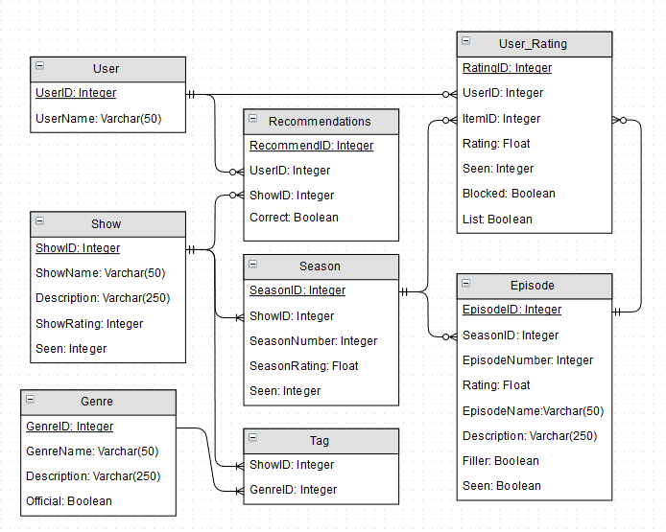

Figure 3.1 Database Relationship Entity Model

The extension itself would use JavaScript to alter the User Interface of Netflix as well as retrieve information for processing. This interface would be based around improving functionality as well as allowing for increased customisability of the display. Example comparisons can be found in figures 3.2 and 3.3.

The extension would also perform a recommender system based upon the information gleaned from the user through the Netflix API. This information would be mined and compared with other users as well as other online sources in order to recommend a show to the user’s tastes. This system would contain feedback functionality for each recommendation in order to further improve the personalisation as well as differentiating it from the existing Netflix recommender system. This has been further detailed in figure 3.4.

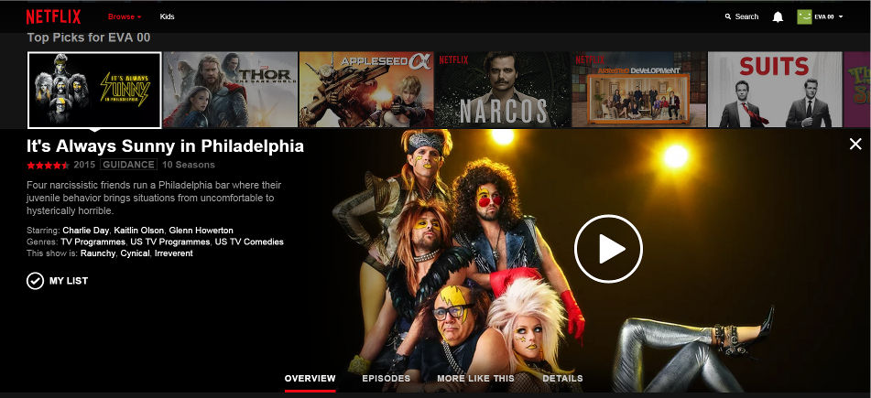

Figure 3.2 The Netflix Website display before modification

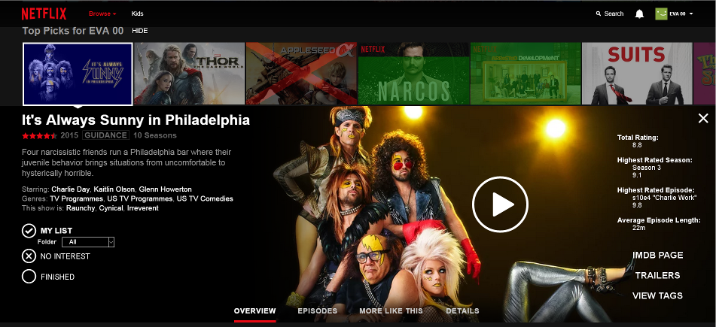

Figure 3.3 The Netflix Website display after proposed modification.  
Note the additional information on the right, the coloured overlay at the top representing user feedback, as well as the unobtrusive user feedback options at the top (HIDE) and bottom left.

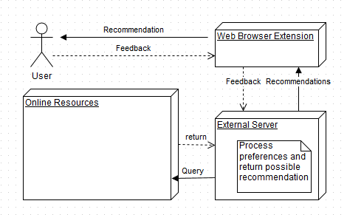

Figure 3.4 Diagram of proposed operation for recommender system.

# 3.3 Problems Faced

## JavaScript Language

In order to create the extension for Google Chrome, it was required to use JavaScript for a large section of the functionality. This required learning JavaScript without any prior experience with the language. This was initially performed primarily online, intending to avail of the many free services available online.

Learning JavaScript proved to be quite a challenge as it was different to many of the languages taught during the course (Java, C++, C) as it was untyped and interpreted, which made certain familiar processes more complicated. Though the syntax for the language is derived from C, the semantics and design are influenced by other languages. The resources available for JavaScript are also more limited than those available for C, C++, and Java as though the documentation was readily available, many of the resources dealt mainly with very simple levels of the language and revolved around subjects already familiar due to past experience with other programming languages, Boolean Logic, Loops, and Arrays for example.

This meant that large a large amount of time was spent analysing tutorials and guides that dealt with already familiar subjects. The book *JavaScript and JQuery: Interactive Front-End Web Development* (Duckett, et al., 2014) was also consulted later in the semester due to the number of problems faced learning the language online. These problems learning the language meant significant delays for the implementation of the application.

## Netflix

After completion of research and the commencement of the implementation of the extension, it was realised that the API for Netflix was no longer publicly available. This caused obvious issues with interfacing between the extension and the web application. Of the existing API that can be found online, a vast majority of it is outdated due to frequent updates by Netflix.

Due to the issues with the availability of the API, it is possible that the project may need to be rethought. It is likely that the initial plan of an extension for Google Chrome may remain, but may be altered in order to work with a different medium while maintaining the ideals and intentions of the project. Thankfully much of the work completed thus far has been research or general enough to allow for a much more painless transition if necessary.

4: Project Plan

# 4.1 Introduction

As mentioned in the previous section, it’s possible that the selected solution to the project may be changed. Regardless of the solution chosen, much of the plan remains the same. Detailed below will be the plan for implementation as well as testing and evaluation.

# 4.2 Possible Modification

Due to the aforementioned issues with the Netflix API, it is increasingly likely that the project implementation will be modified from the initial Netflix plans. The new project solution may entail a more general approach based around assessing user browsing habits and providing assistance accordingly. An example of this would be opening a news site automatically at a certain time in accordance with past experience.

# 4.2 Implementation

Plans for implementation are to begin during the break in January. Work remaining to be done at this time consists primarily of the completion of the extension. Due to problems with JavaScript and the Netflix API, this has been delayed far behind schedule. The remaining stages of the implementation are to be complete before the return to college next semester. This work mostly entails the completion of the primary functionalities of the application, the user profiling, in order to transition to the testing and evaluation of the application.

# 4.2 Testing and Evaluation

The evaluation of the application will be a major part of the project. This will be done both personally, using both test cases as well as user testing, and also by posting the application onto the Google Chrome Web Store. The test cases will be performed and assessed personally using select data and preconditions. This will allow proper recording of certain situations and correct determination of feature functionality. This will be performed throughout the semester and the extension may be altered according to the results to these tests and evaluations.

Further testing will be performed by selected individuals who will be asked to install the extension and report upon its functionality as well as possibly using the data collected from these for further anonymous test cases. The final form of evaluation will be to submit the application to the Google Chrome Web Store and record the user reviews and score given to the extension. These results will then be compiled to be added to the final report.

# Bibliography

Barakova, E., Mestrom, R. & Willemsen, W., 2011. *The Application of Learning Algorithms in the Development of Natural Interaction,* Eindhoven, The Netherlands: ACM SBN 978-1-4503-0754-3.

Duckett, J., Ruppert, G. & Moore, J., 2014. *JavaScript and JQuery: Interactive Front-End Web Development.* First ed. s.l.:Wiley.

Godoy, D. & Amandi, A., 2005. *“User Profiling in Personal Information Agents: A Survey,* New York, USA: The Knowledge Engineering Review.

Holland, S., Ester, M. & Kießling, W., 2003. *Preference Mining: A Novel Approach on Mining User Preferences for Personalized Applications,* s.l.: 978-3-540-39804-2.

Holland, S. & Kießling, W., 2004. *User Preference Mining Techniques for Personalized Applications,* s.l.: s.n.

Iglesias, J. A., Angelov, P., Ledezma, A. & Sanchis, A., 2012. *Creating Evolving User Behavior Profiles Automatically,* s.l.: IEEE.

Krug, S., 2014. *Don't Make Me Think, Revisited: A Common Sense Approach to Web Usability.* Third ed. s.l.:New Riders.

Murphy, K. P., 2012. *Machine Learning: A Probabalistic Perspective.* First ed. s.l.:The MIT Press.

Nakatsuji, M., Yoshida, M. & Ishida, T., 2009. *Detecting innovative topics based on user-interest ontology,* Tokyo, Japan: Elsevier.

Norman, D., 2013. *The Design of Everyday Things: Revised and Expanded Edition.* Revised ed. s.l.:Basic Books.

Perkowitz, M. & Etzoni, O., 1999. *Towards adaptive Web sites: Conceptual framework and case study,* Seattle, USA: University of Washington.

Rossi, G., Schwabe, D. & Guimaraes, R., 2001. *Designing Personalized Web Applications,* Hong Kong, China: 10th World Wide Web Conference.

Sipper, M. et al., 1997. *A Phylogenetic, Ontogenetic, and Epigenetic View of Bio-Inspired Hardware Systems,* Lausanne, Switzerland: IEEE.

Vogeley, K. & Bente, G., 2010. *"Artificial humans": Psychology and neuroscience perspectives on embodiment and nonverbal communication,* Cologne, Germany: Elsevier.

Witten, I. H., Frank, E. & Hall, M. A., 2011. *Data Mining: Practical Machine Learning Tools and Techniques.* Third ed. s.l.:Morgan Kaufmann.